Whether there Is a Population Quality Concern in Taiwan?

BA3 B04701213 莊夢蝶

**Abstract**

Since the fertility rate gaps between high-educated family and low- educated family are getting bigger in the world, there is a concern about whether it will cause the population quality to go down and lead to the result of raising the violent crime rate, which is a speculation basing on some logic deduction. Thus, I want to check out whether there is really such existence of this logic deduction in the reality and whether it’s happening in Taiwan.

Because of some data limitation, I had simplified my model. However, what I need is the relationship between fertility rate and violent crime rate, not predict violent crime rate, which allow me to simplify the model. In my model, there is a way to control the average income per person to three different level: low, medium, high. In according to the logic deduction I want to check out with, when I control the low fertility rate to high level, there will be a negative relationship between fertility rate and violent crime rate, positive for opposite income level.

However, in the end they are all negative in three different level. It’s somehow because of that I used only the data in Taiwan and had simplified my model. There are data detail limitation, data size limitation and the most important thing that the diversity in Taiwan is not that large as in a big country.

In conclusion, there is a possibility the logic deduction is really a fact that every developed country need to pay attention to and also a possibility that there is a on-going concern in Taiwan.

**Project motivation**

At first, since the data collection part is the most difficult part of the whole project achievable, which I’ve learned from the group project, I browse online for the accessible data in Taiwan. Meanwhile, I read some news for the interesting information that can light my topic.

That’s when I read an article about differences between high-educated(developed) regions’ fertility rates and low-educated(developing) regions’ become larger in the whole world trend. Thus, we need to concern about the population quality going down since children will mostly growing up in an environment which is not good enough. In addition, with population quality going down, crime rate goes up logically.

As a result, I want to figure out whether there is a same problem in Taiwan whether the same above theory can be applied on Taiwan’s situation now or is there a potential possibility for Taiwan in the future.

**Project topic**

as above mentioned, I set my individual project topic as

“whether there is a population quality concern in Taiwan?”

**Project methodology**

- data collection

In Taiwan , there is really some limitation about data collection, which had made me stuck in for a long time, almost thinking about changing the topic. Why? Since I want to do a fertility rate with low/high educated family, the ideal situation is that there is a record about the burned infant with their parent’s economic situation or with their parent’s education situation. However, yes, they do have a similar record about that, which only with whole Taiwan situation not in each administration districts that makes a limitation about data size with only a few data. The worst is that data in Taiwan always give you only the “value” you want. Specifically, if you want a birth record with education situation, you can only get the value they have deal with the raw data no other relative variable. As a result, even that you have the values , you don’t know the proportion of these value takes in the whole Taiwan fertility rate. Usually, if you want some data about something in Taiwan, you get exactly the values, which make you can’t do other useful analysis. It’s the first problem I met.

Thus, I have to simplify my idea that allow me to take only the exactly value to deal with. Since I simplify my idea, the data which to be collect is quite simple as my topic is considerate specific. I collected the crime rate, fertility rate, education rate (percentage of population over people who are aged 15 years-old and above by the education level over and above college) and economic situation (average disposable income per person per year).

- parameter consideration

It’s simple for me to decide the variable to put in the model because my topic is relatively direct to the point as well as my data collection. Briefly,

y = crime rate,

variable1 = fertility rate,

variable2 = education rate,

variable3 = economic situation.

- model design

The summary models I’ve designed as follows

Model1 : which is quite simple to take a overlook(plot1)

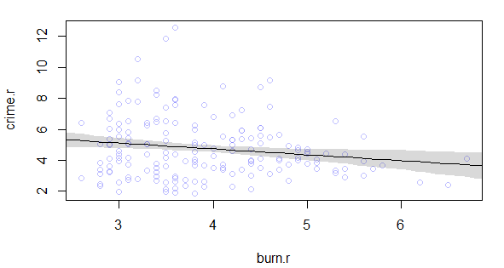Crime rate ~ Normal(µ,σ)

µ = α + β * fertility rate

α ~ Normal (xx,xx)

β ~ Normal (xx,xx)

σ ~ dunif ( xx,xx)

plot1. Overlook for fertility rate and crime rate

Model2 : put all variable in, find out that there is a collinearity relation between education and economic

Crime rate ~ Normal(µ,σ)

µ = α + β * fertility rate + β1 * education rate + β2 * economic situation

α ~ Normal (xx,xx)

β ~ Normal (xx,xx)

β1 ~ Normal (xx,xx)

β2 ~ Normal (xx,xx)

σ ~ dunif ( xx,xx)

Model3 : put either of education or economic in with fertility rate, take interaction effect into consideration

Crime rate ~ Normal(µ,σ)

µ = α + β * fertility rate + β1 * education rate/economic situation * fertility rate

α ~ Normal (xx,xx)

β ~ Normal (xx,xx)

β1 ~ Normal (xx,xx)

σ ~ dcauchy ( xx,xx)

in the end, use WAIC to compare these model(plot2), which model3 with economic situation is outperforming.

Model3

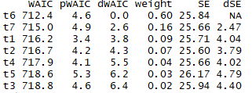

Model1

Model3

Model2

Model3

Model3

plot2. WAIC compare for all models

As the result, in the following discussion we use model3 with economic situation to all the plot and analysis.

- plot outcome

Since I have simplified my idea as my model, the important thing is to analysis the relationship revealed by my model. Below are the counterfactual plot with my model.

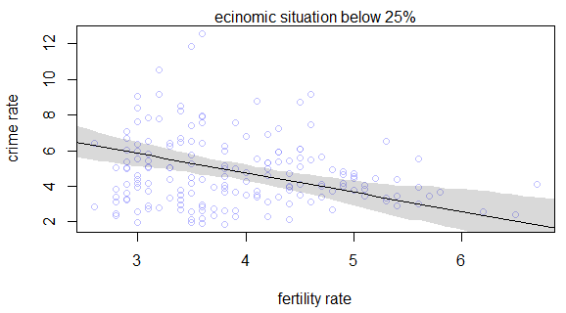

plot3. Set ecnonomic situation at 1st quarter value into the model

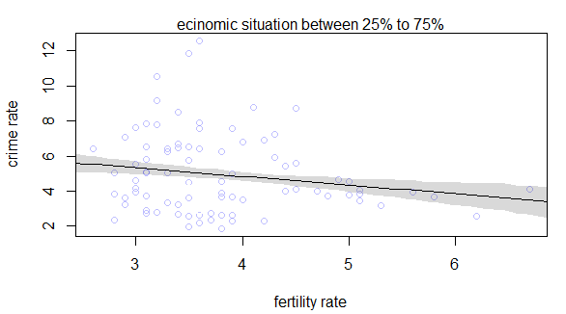

plot4. Set ecnonomic situation at mean value into the model

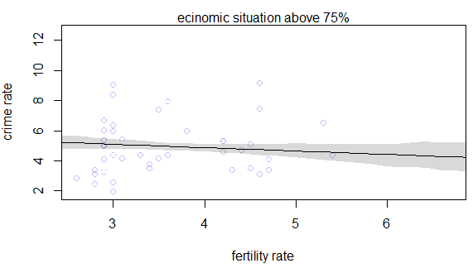

plot5. Set ecnonomic situation at 3rd quarter value into the model

- plot analysis

We can tell from above plots that although the slopes become flatter as the economic situations become better. However, overall we can say that all the slopes are acting negatively, which means that the fertility rate in Taiwan do has negative relationship with crime rate.

**Project conclusion**

- conclusion

As I mentioned above, at first, I expected the model will print out that when the economic situation or education rate is set in a high value, fertility rate and the crime rate would have significant negative relationship. However, outcomes show that no matter the economic situation value is set, they all end up with a negative relationship. Below is some explanation I think for these kind of outcome.

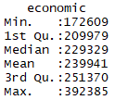Since Taiwan is a small place, there isn’t large difference between countryside and city, not like the big country like China nor America. It can be proved by summary data(plot6). Even with the extremely low economic situation has about seventeen thousand.

plot6.summary data

Overall, we may be able to conclude that the population quality concern has possibility chance happened in Taiwan.

- interesting discover

When I was plotting the counterfactual data, I’ve set the economic situation level to extremely highest value. Plot shows that there will be a positive relationship between fertility rate and crime rate(plot7), which is back to normal people’s recognition. 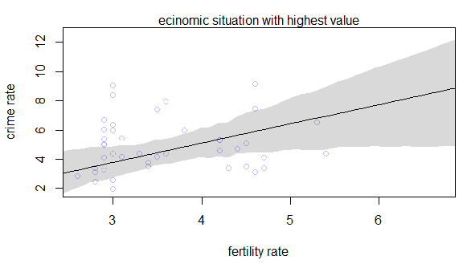

plot7. Set ecnonomic situation at highest value into the model

The plot shows that there is a chance if the government can raise the average income per person to a quite high level, then there may be no population quality problem in Taiwan for the data now. It’s hard to said that with data from high-economic situation, there will have positive relationship between fertility rate and crime rate. However, I don’t have more detail data to analysis inner issue and neither it’s the point in this project. I just put it out as a interesting find out in this model created from these data.

**Project improvement**

- data collection

If the government in Taiwan can record the data in a much more useful way, it will be more possibility to let people find out interesting fact in Taiwan. For example, a birth record can be record with parents’ age, education level, economic situation and some more background, not only the number of infants.

- model improve

As the data limitation, my model only takes the whole summary rate in each district into consideration, may somehow sweep statement about the outcomes. If there is a more detail data can be accessible, the population quality issue or the model outcome can be checked more carefully.

**Reference**

<http://blog.udn.com/kellygun20000/52163230>

**Shiny**

<https://neva8220.shinyapps.io/b04701213_individualProject/>